Queastion-1

Tasks To Be Performed:

Tasks Hello Again Make a script that prints three different messages using echo:

● “Hello World”

● “Hello Saurabh”

● “Hello DevOps”

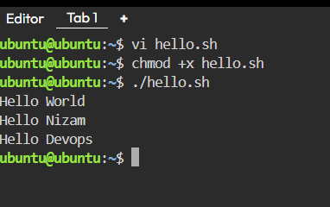

Queastion-2

Greeting with Name Ask the user for their name and print a welcome message with that name.

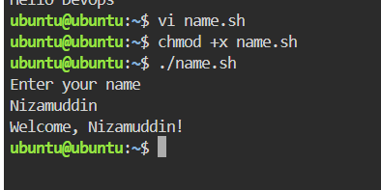

Queastion-3

Tasks To Be Performed: Take input from the user for Name, Age, State, and Designation step by step. Then print all the details in a single line

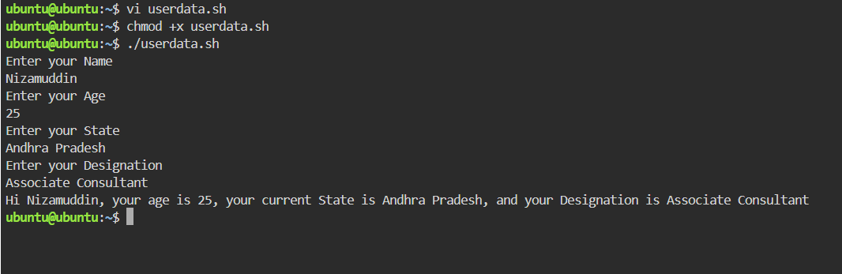

Queastion-4

Task To Be Performed: Ask the user for their age. ● If age ≥ 18 → print “You are eligible to vote” ● Otherwise → print “You are NOT eligible to vote”

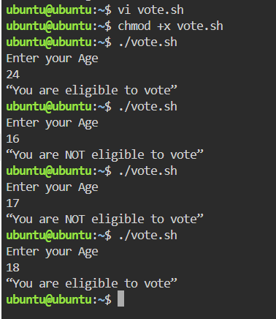

Question-5

Task To Be Performed: Take two numbers from the user. ● If the first number is greater → print “First number is greater” ● If the second number is greater → print “Second number is greater” ● If both are equal → print “Both numbers are equal”

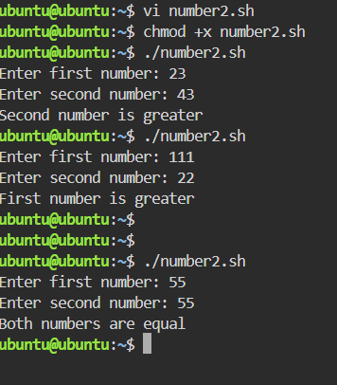

Question-6

Task To Be Performed: Take marks (0–100) as input. ● If marks ≥ 90 → Grade A+ ● If marks ≥ 75 → Grade A ● If marks ≥ 50 → Grade B ● Otherwise → Fail